Rodrigo Brasil 10/2023

### **Part 1: Topology 1/2**

Initial Topology

### **Part 2: Staging**

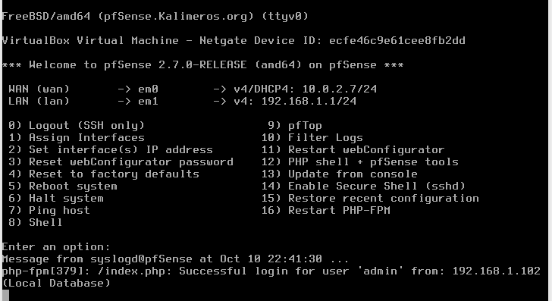

pfSense

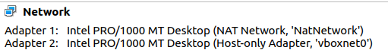

pfSense network adapters

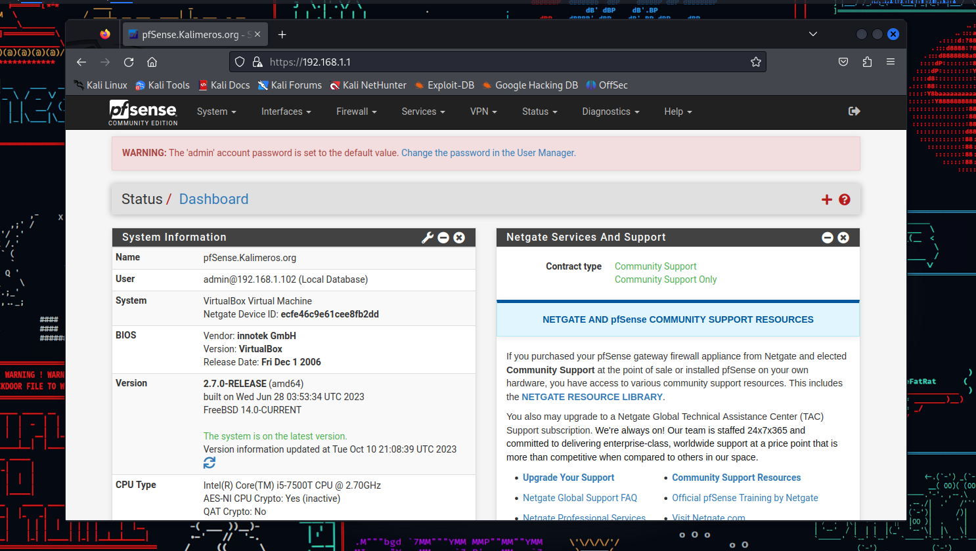

Kali VM



Kali VM network adaptor

### **Part 3a: Captive Portal**

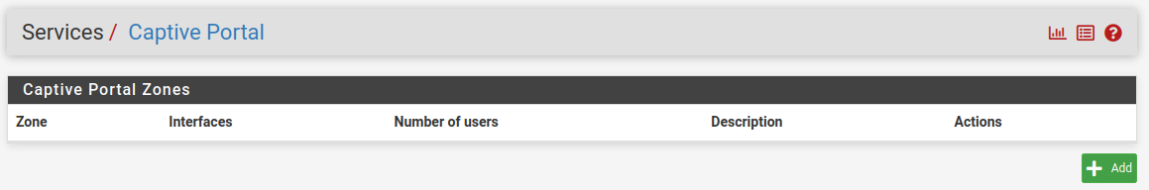

On Services / Captive Portal

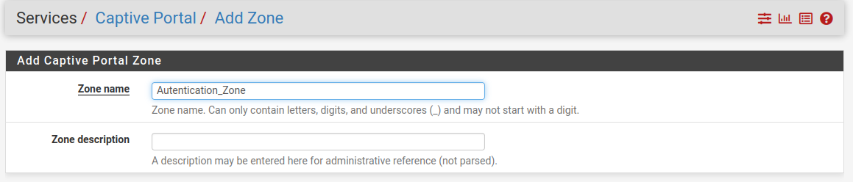

Add a zone, with a zone name and a zone description (optional)

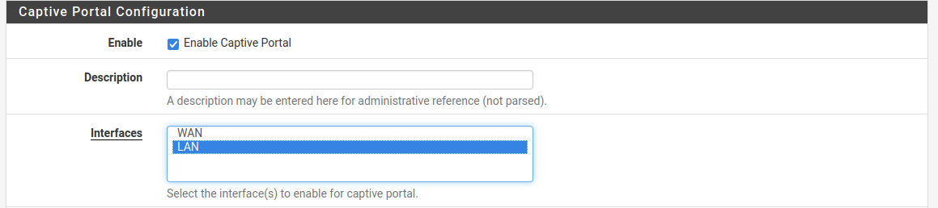

Click the Enable Captive Portal Box and on Interfaces select LAN

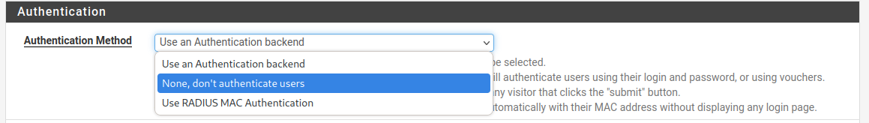

On Authentication Method Select “None, don't authenticate users” and save

For some reason the kali VM did not have network connection but on a windows 10 VM did, but it was very unstable. Sometimes it had it and some other times it didn’t.

couldn't find out why.

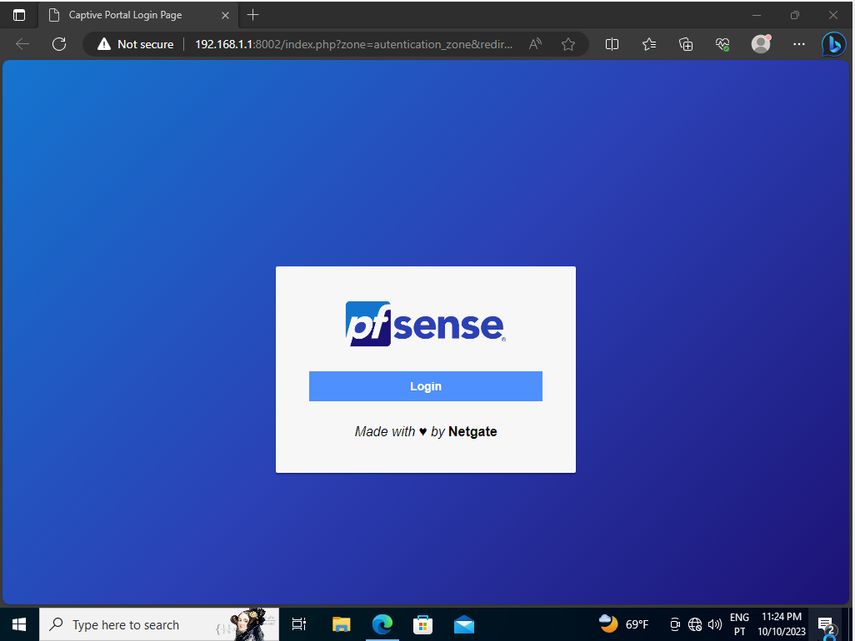

The pfSense Authentication Portal

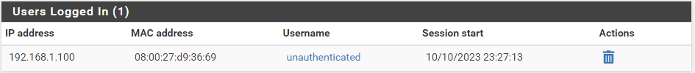

on Status / Captive Portal

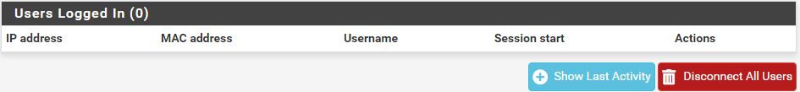

Clicking the trash icon to remove the user

### **Part 3b: Captive Portal Authentication**

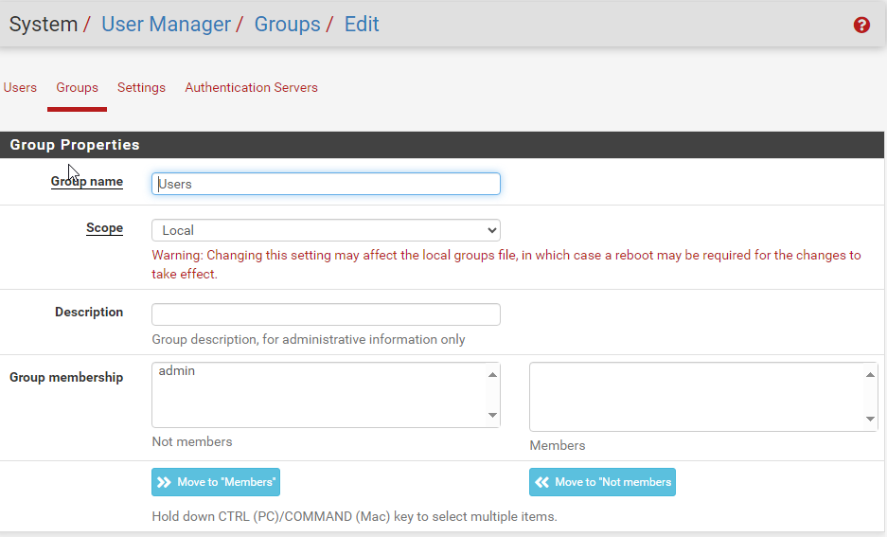

On System / Use Manage / Groups create a users group

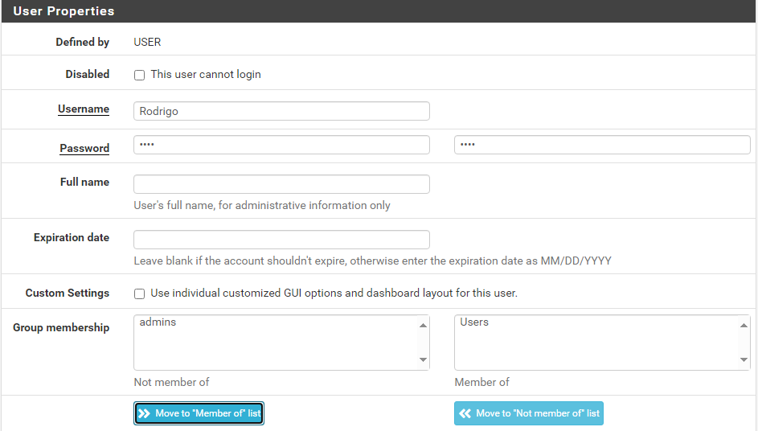

On System / Use Manage create a user, give it a username, a password, assign it the previous create group and save.

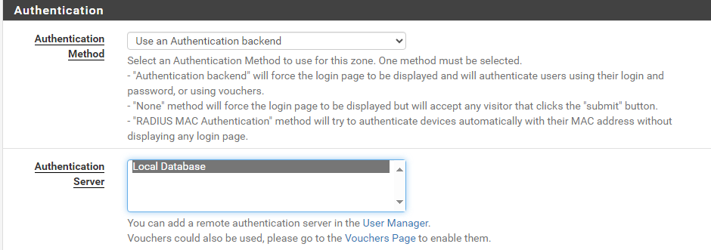

After creating a group and user, go back to Services / Captive Portal and change the Authentication method to “Use an Authentication backend”.

Select Local Database on the Authentication Server list.



Verify if the Local Authentication Privileges box is checked.

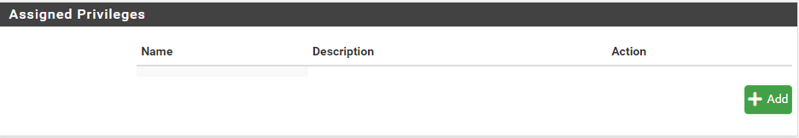

To give the above privileges mentioned, go back to the User Management / Groups to add them.

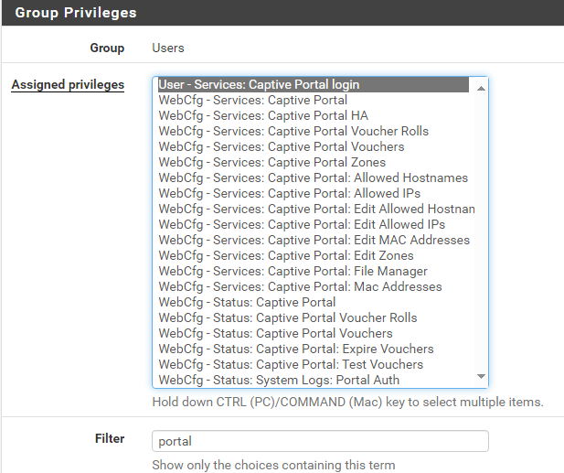

In there use the filter to easily find the appropriate privilege by searching “portal” and assign the “User - Services: Captive Portal login” privilege.

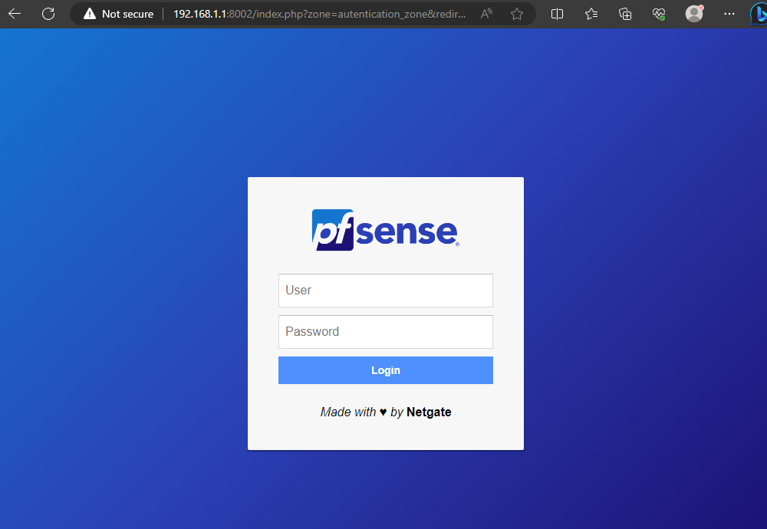

Now in the Authorization page it asks for login credentials

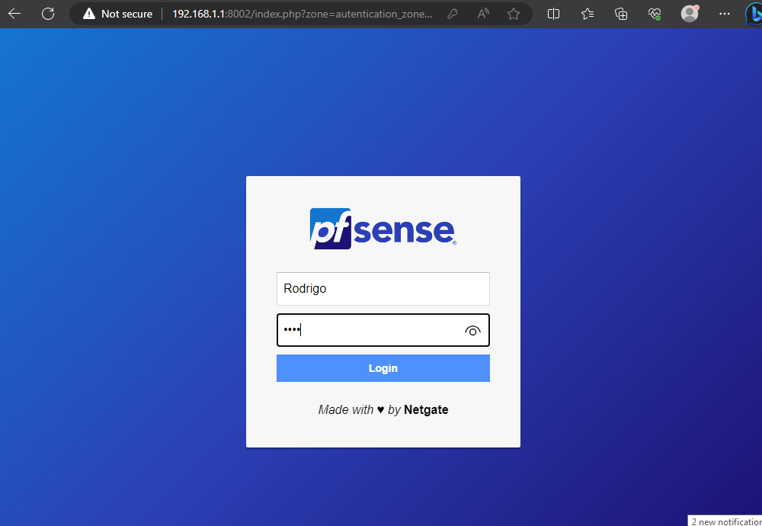

Enter the previous created user.

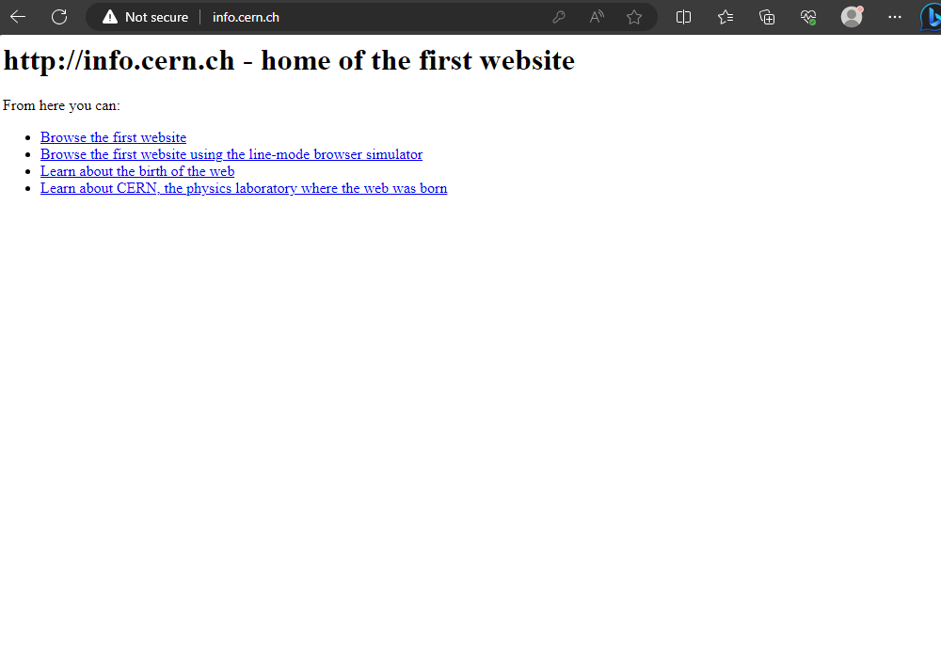

And we are in.

The captive portal changed because we made it so we can only enter if we are a valid user, have credentials and have permission to enter.

I cannot enter with the admin account, not sure why yet.

### **Part 4: Deploy FreeRADIUS**

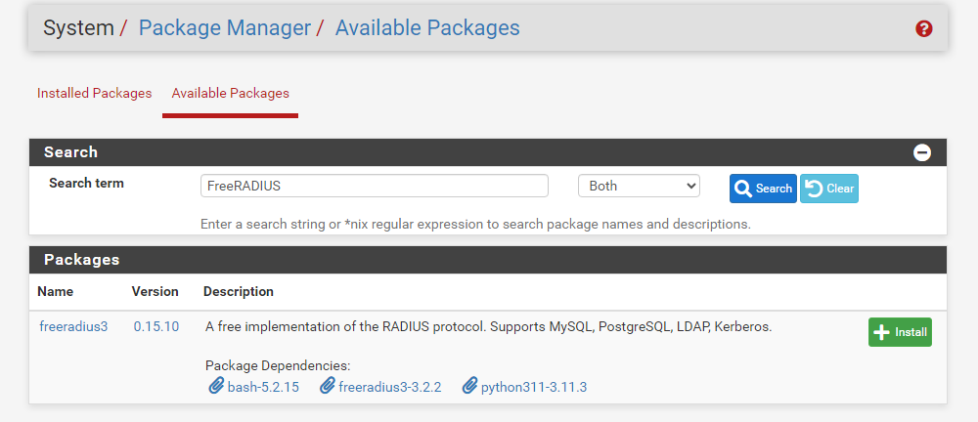

pfSense does not come with FreeRADIUS preinstalled, we have to install it ourselves by going to System / Package Manager / Available Packages and search for “FreeRADIUS” on the search bar, click the dark blue search button and install it.

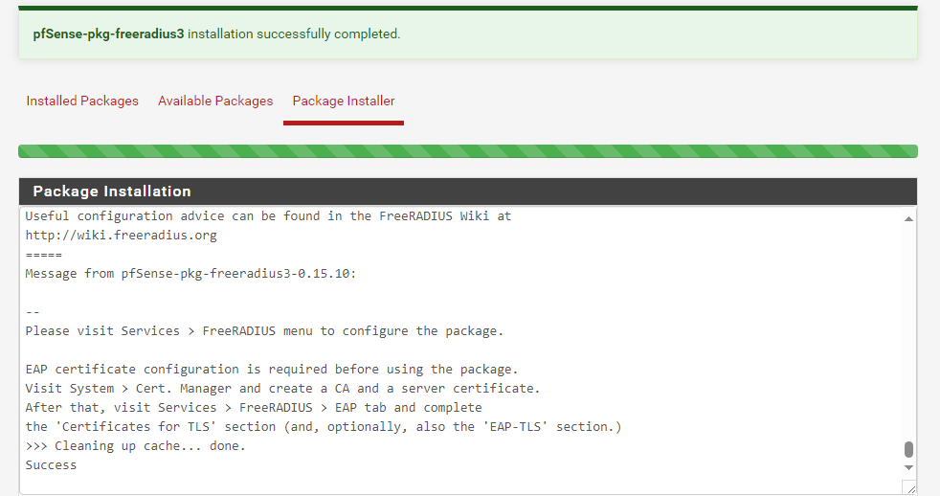

The installation will look like this, if it installed it will give a green info saying “*package name* installation successfully completed”.

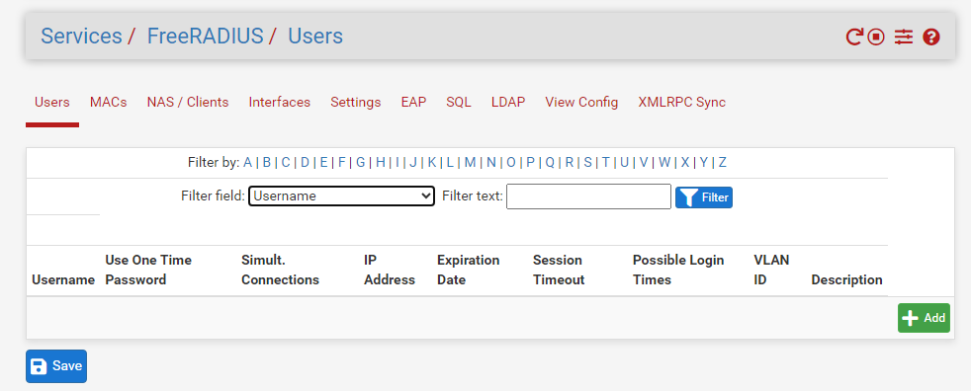

Now in the Services tab FreeRADIUS is available.

Navigate there Services / FreeRADIUS and create a new user by clicking the green +Add button.

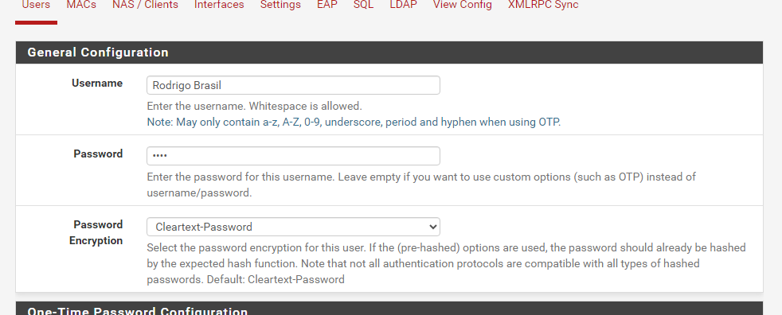

Just add a Username, a password and save.

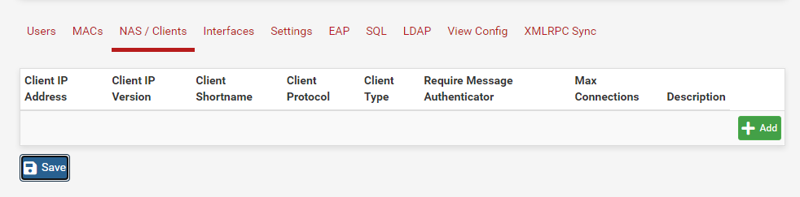

Navigate to the NAS / Clients and click the green +Add button

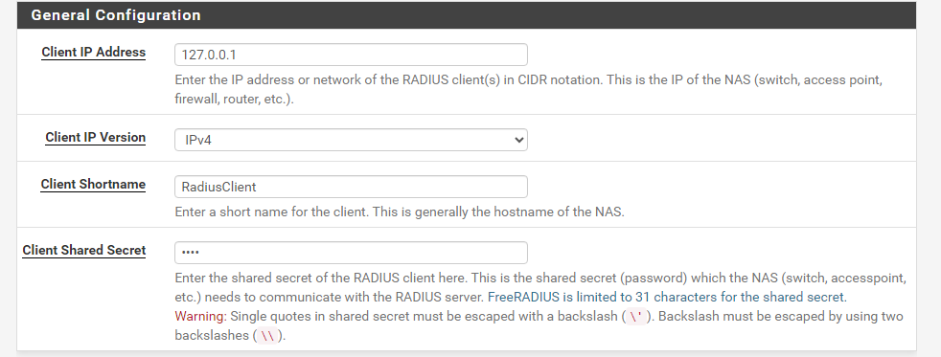

Add the client IP address (127.0.0.1 means local host), give a client shortname, a Client Shared Secret and save.

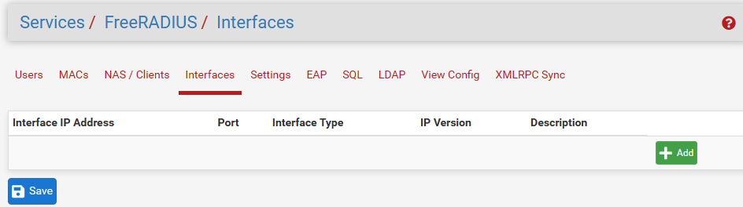

Next we are going to add an interface by going to services / FreeRADIUS / Interfaces

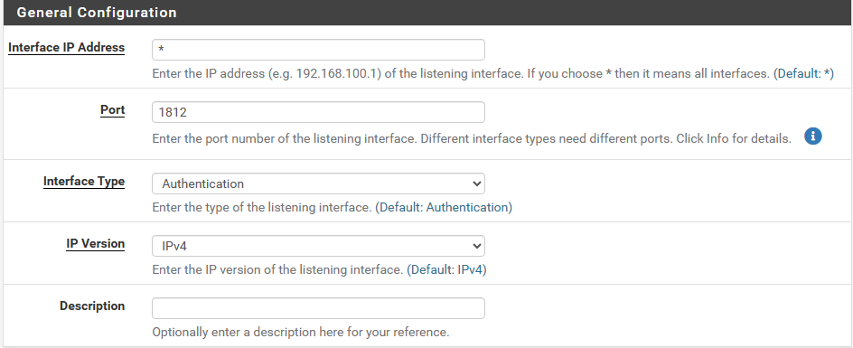

Here we are going to leave everything on default and save

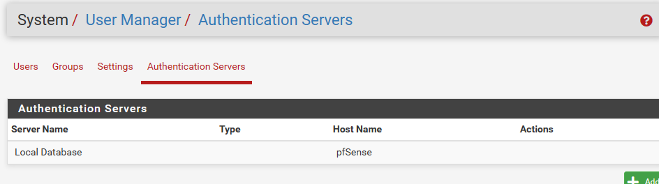

Now we have to go to System / User Manager / Authentication Servers and add one.

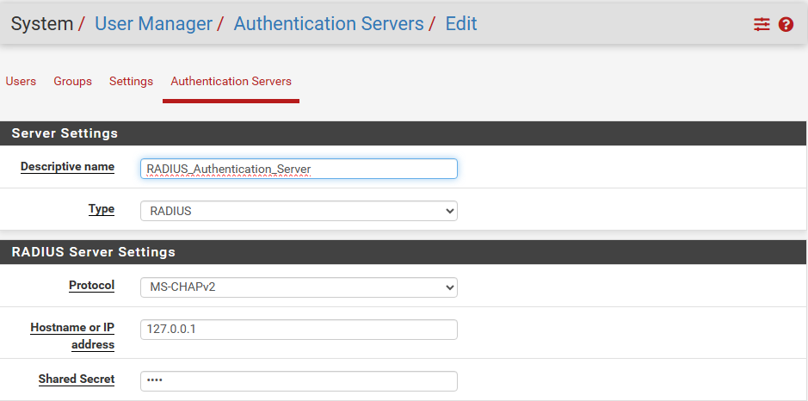

Here we are going to give a descriptive name of choice, change the type to RADIUS and give it the Shared Secret key we gave a few steps before.

Now we are going to test the User Authentication by going to Diagnostics / Authentication, Selecting the Authentication Server that was created on a previous step, the username and password.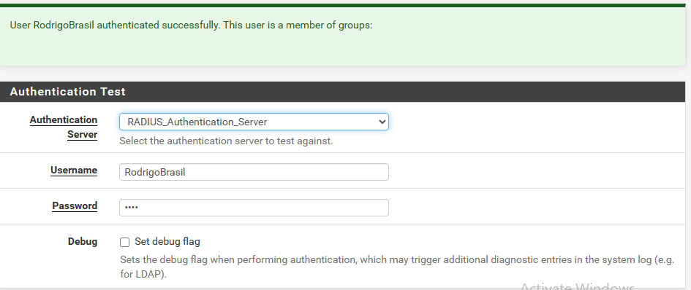

### **Part 5: Integrating FreeRADIUS with Captive Portal**

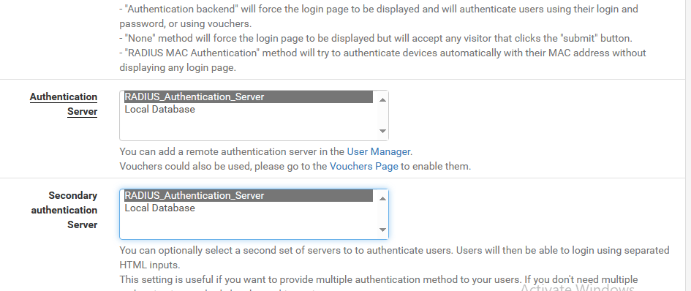

Now to integrate the FreeRADIUS with our Authentication portal created before we have to go back to Services / Captive Portal and change the Authentication Server to the one created on a previous step which in our case is “RADIUS_Authentication_Server” and save.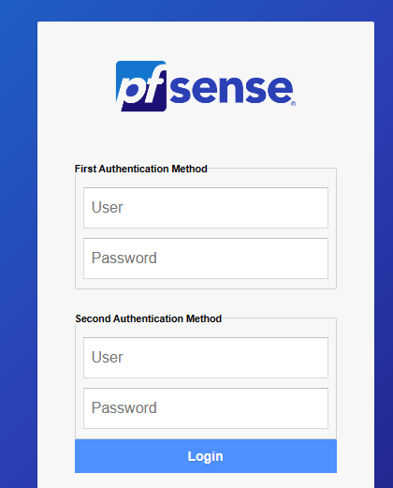

Now we have 2 Authentication Methods, First for RADIUS and Second for Local both working as expected.

### **Part 6: Logs**

### **Part 7: Topology 2/2**